ER Diagram for University Management System

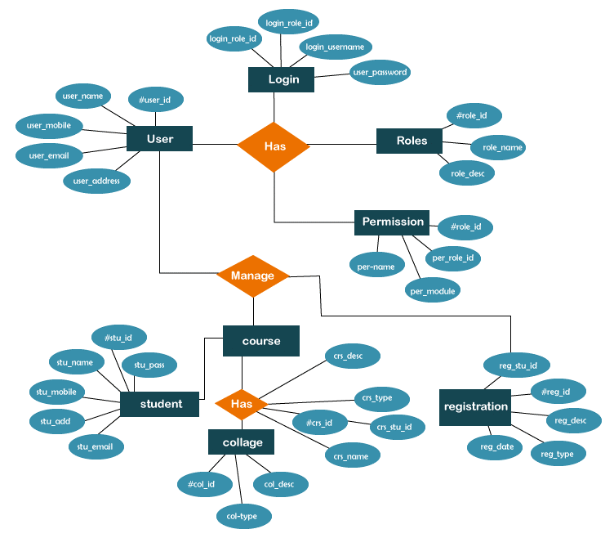

|  |  |
| --- | --- |
| ER Diagram Explanation:- | |
| * The ER diagram will show entities as rectangles, attributes within the rectangles, and relationships between entities using lines connecting them. * Each relationship line should be labeled with the cardinality of the relationship (one-to-one, one-to-many, or many-to-one). |

Entities:

1. **User:**
   * Attributes: UserID (Primary Key), FirstName, LastName, Email, PhoneNumber, etc.
2. **College:**
   * Attributes: CollegeID (Primary Key), CollegeName, Location, Dean, etc.
3. **Course:**
   * Attributes: CourseID (Primary Key), CourseName, Credits, Department, etc.
4. **Registration (Student Enrollment):**
   * Attributes: RegistrationID (Primary Key), StudentID (Foreign Key), CourseID (Foreign Key), RegistrationDate, Grade, etc.
5. **Login:**
   * Attributes: LoginID (Primary Key), UserID (Foreign Key), Username, Password, LastLoginTimestamp, etc.
6. **Roles:**
   * Attributes: RoleID (Primary Key), RoleName (e.g., Student, Faculty, Staff, Admin), Description, etc.
7. **Permission:**
   * Attributes: PermissionID (Primary Key), PermissionName (e.g., EnrollStudent, AssignGrade, ManageCourses, etc.), Description, etc.

Relationships:

1. **User-Registration:**
   * Each user (Student) can have multiple registrations (enrollments).
   * Cardinality: One-to-Many
2. **Course-Registration:**
   * Each course can have multiple registrations (students enrolled), and each registration corresponds to one course.
   * Cardinality: One-to-Many
3. **College-Course:**
   * Each college can offer multiple courses, and each course belongs to one college.
   * Cardinality: One-to-Many
4. **College-User:**
   * Each college can have multiple users (faculty, staff, students), and each user belongs to one college.
   * Cardinality: One-to-Many
5. **User-Login:**
   * Each user has one login information, and each login corresponds to one user.
   * Cardinality: One-to-One
6. **User-Roles:**
   * Each user can have multiple roles, and each role can be associated with multiple users.
   * Cardinality: Many-to-Many
7. **Roles-Permission:**
   * Each role can have multiple permissions, and each permission can be associated with multiple roles.
   * Cardinality: Many-to-Many

These relationships allow you to represent the association between users and their roles, permissions, as well as the login information. Adjust the attributes and cardinalities based on the specific requirements and functionalities of your University Management System.